22.8: a) No charge enclosed so 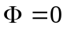
b) 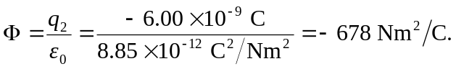
c) 